18.03.2020 – АЕ – 8б – 6.час
/ Ж.Тумбева/
You have to write the article in your homework notebook or using MS WORD !
- Write an article
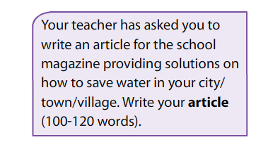
NB!!!
please send me the article to ZHANETATUMBEVA@ABV,BG
OR VIA SHKOLO.BG “сЪОБЩЕНИЯ”
UNTIL 19th March ! KEEP THE INSTRUCTIONS!

Stay healthy

