18.03.2020 – АЕ – 8б – 6.час
/ Ж.Тумбева/
- Send me / snapped/ p.83, SB/ex. 2,3,4,5,6 done in your SB or in your classwork notebook until today.

- Do the task

2.1.
Write 4 grammar mistakes:
1.
2.
3.
4.
2.2.
1.
2.
3.
2.3. 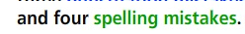
1.
2.
3.
4.

- There are 10 grammar mistakes in the text bellow. You have to find them and correct them.
The Titanic was biggest and expensivest ship in
the world. He was built in Ireland in
1911. First voyage of the Titanic
was from Europe to America. In a ship
there were about 1200 passengers. The rich passengers
was on the upper decks and the poor
passengers on the lower decks. On 14 April
1918 the Titanic hitted an iceberg. The iceberg
make a big hole in the side of
the Titanic and the ship began to sink.
Some people survived because he got into a
lifeboat. Many other people died when they fall
into the freezing water.
1
2
3
4
5
6
7
8
9
10

- Do the listening task, using DIGIBOOK track- SB,p.115, ex.8b
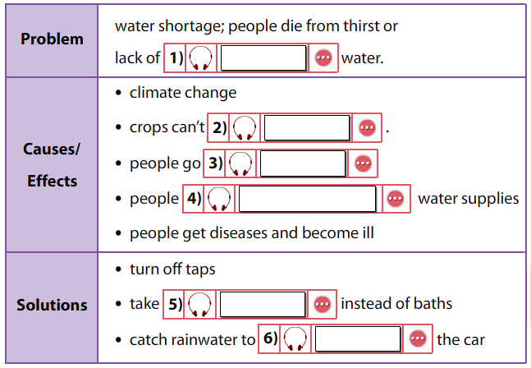
Answer HERE:
1)
2)
3)
4)
5)
6)
NB!!!
Today you have to work on this word document.work only here. when you are ready, please send me the file to ZHANETATUMBEVA@ABV,BG
OR VIA SHKOLO.BG “сЪОБЩЕНИЯ”
UNTIL TODAY! KEEP THE INSTRUCTIONS!

Stay healthy

