TRAINING ACTIVITY »SAFETY COMMUNICATION IN REAL AND VIRTUAL SPACE«

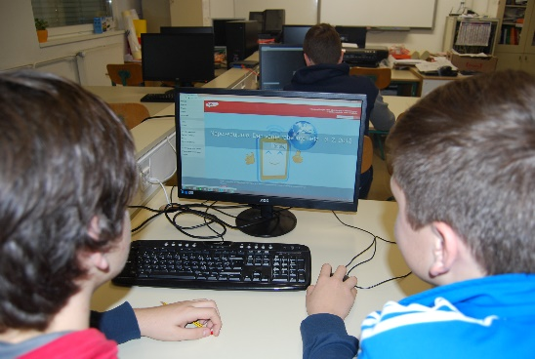
The training “Safety communication in real and virtual space” was performed by the Slovenian organisation Safe.si that promotes and educates students, parents and teachers about the safe use of internet and mobile devices. Then, the survey about pupils’ use of modern technologies was carried out.
In the training, the pupils of the 3rd (8-year-old) , 6th (11-year-old) and 8th (13-year-old) grade were included. The content of the training was adjusted to students' age, as well as their needs that have been observed at working with them. The training was also very interested for parents.
For the pupils in the 3rd grade the training »Don't act as a sheep on the internet« and for pupils in the 6th grade the training »Social media and privacy protection on the internet” was organized.
For the pupils of the 8th grade the theme of the training was “Addiction to new technologies”.
Younger pupils were more reserved about the topic as older students. The 8th graders had many questions about the use of internet and modern technologies.

After the training, the focus was set on the older group of pupils (26 pupils) and we ask them three questions:
- Which device do you use the longest time on a daily basis?
The majority of pupils use on average 2 hours a day their smartphones (Snapchat, Facebook, Instagram, Youtube).
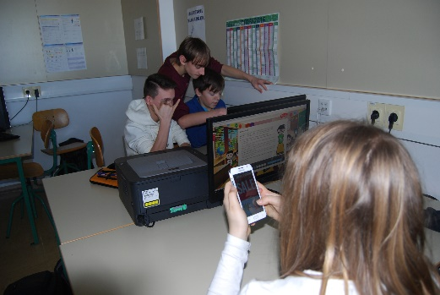
b) Have your parents ever restricted the use of a phone or a computer?
With 42 % of interviewees, the parents restricted the use of technologies (mostly for one week).
c) Do you have a bad experience at using modern technologies in communication with your friends?
23 % of interviewed pupils have a bad experience. Most students are aware of the fact that making photos and posting them on the internet can cause problems, as well as using the phone in school.

