Logos of the Erasmus+ UK National Agency partnership organisations British Council and Ecorys UK, and the European Commission’s Erasmus+ logo.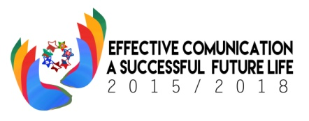

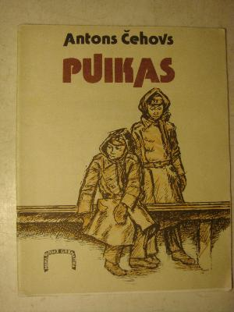In January the students of Class 4 and their parents read the story “The Boys” written by one of Russia's most influential writers of plays and short stories Anton Chekhov.

The story in English:

<http://www.eldritchpress.org/ac/theboys.htm>

21.01.2016. the Russian language and literature teachers from different Jelgava city schools were invited to attend the open lesson given by Mrs Marina Beitane.

The teachers had opportunity to observe the lesson and they were informed about our project later. At the lesson the students talked about the text ,worked in groups and drew the comics.

